1. Create a private Gitlab repo named "i-am-a-git-noob"

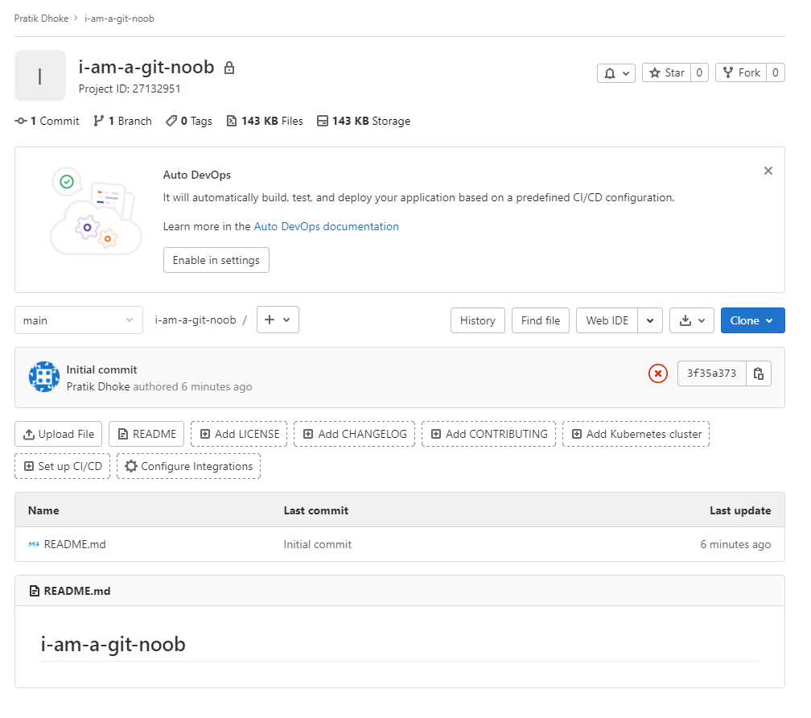

1. Create a new repository on local in an empty directory  
   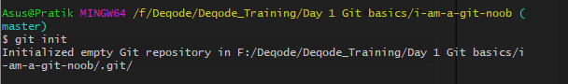

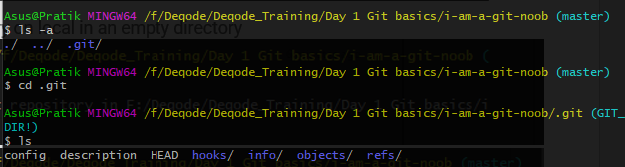

1. Point remote of your local git repo to the newly created repo on Gitlab

  
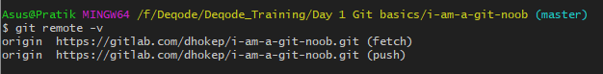

1. Print current git configs on terminal  
   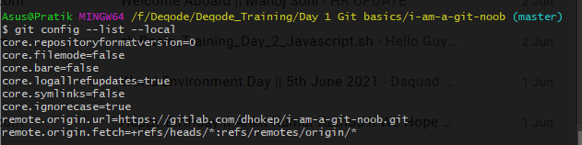
2. Update git config with your name and email address (only for current repository)  
   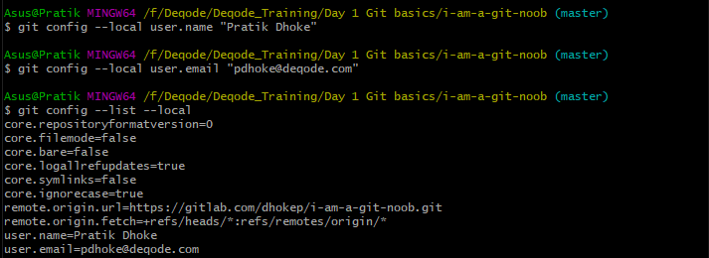
3. Create a file named "test1.txt"

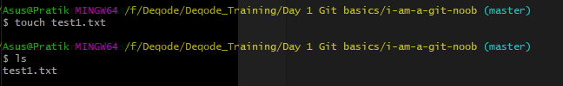

1. Added line with text "first line in file" in "test1.txt".  
   
2. Push this file to your Gitlab repo.  
   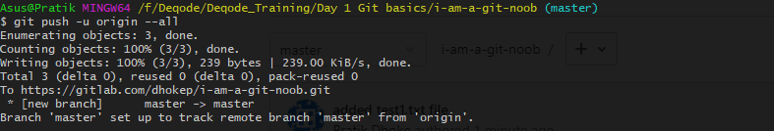
3. Append line with text "second line in file" in "test1.txt".  
   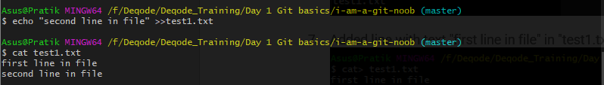
4. Add file to the staging area.  
   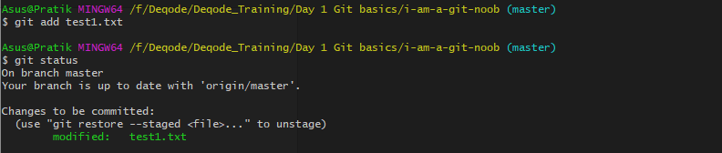
5. Check the status of the file in all staging area  
   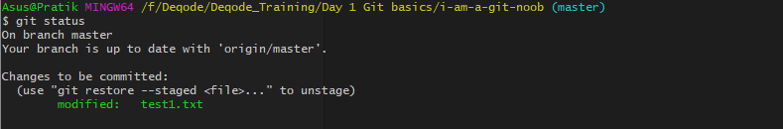
6. Append line with text "Third line in file" in "test1.txt". (Note status of files across different areas).  
   
7. Remove "test1.txt" from the staging area.  
   
8. Create commit with message "My First Commit"  
   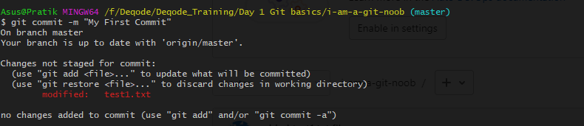
9. Push commit to the remote repo   
   
10. Update message of last commit "My First Commit" to "My Second Commit"  
    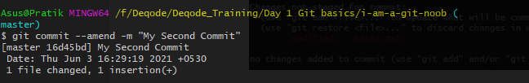
11. Push commit with the updated message to the remote repo  
    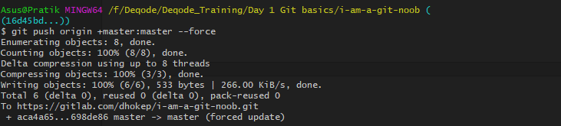
12. Check the difference between the last and second last commits.  
    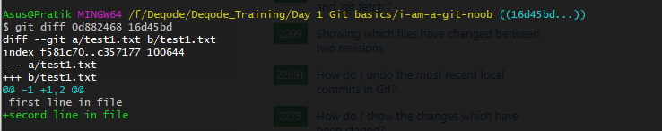
13. Revert the last commit and check the updated commit logs history.  
    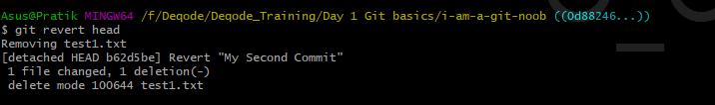
14. Append line with text "Fourth line in file" in "test1.txt" and commit it.  
    
15. Update the last commit such that the "test1.txt"  also contains "Fifth line in file" (without creating a new commit)  
    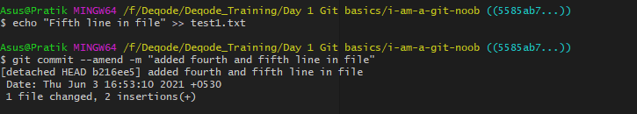
16. Push the updated commits to the remote repository  
    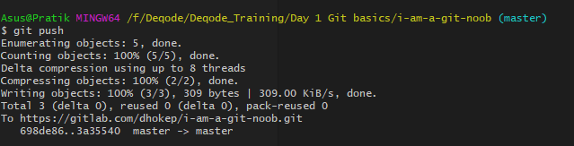
17. Append some content in "test1.txt" file  
    
18. Pull all the content from remote repository to local repository  
    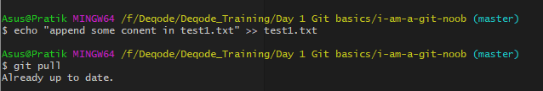
19. Clone the remote repository to some other directory in your local system.  
    